About this journal
Each month will begin with a specific intention for our Archdiocesan Synod. We encourage all the faithful of the local Church to join us in praying together for that intention.

There will be a brief reflection for each week followed by a recommended Scripture passage for the day and a prompt to get you started. Since the Scripture passages will come from the daily Mass readings they can be found here: http://www.usccb.org/bible/readings.

Please remember that this journal is a meant as an offering, not an obligation. We encourage you to use it in whatever way serves you best.

Why Pray?
The very first paragraph of the Catechism of the Catholic Church begins:

God, infinitely perfect and blessed in himself, in a plan of sheer goodness, freely created man to make him share in his own blessed life. For this reason, at every time and in every place, God draws close to man. He calls man to seek him, to know him, to love him with all his strength (CCC 1)

God is drawing close to us. Are we willing to seek him, to know him, to love him with all our strength? We begin the journey of seeking, knowing and loving him in prayer.

What is prayer?
God desires each of us to enter into a vital and personal relationship with him. This relationship is prayer (CCC 2558). Just as each relationship between two people is unique, so is each relationship between a person and God. Consequently, there is not a given formula for prayer. It is more important that a person prays than how a person prays.

We have the gift, however, of being able to learn from one another, from the saints and from people in the church who are particularly gifted at prayer. Therefore we will be offering suggestions from the experts to help us get started.

We encourage each person to discover how God speaks most clearly to him or her. Feel free to try different forms of prayer, but do not feel pressured to try them all. In fact, if you find a particular way of prayer leads you to intimacy with God, continue to pray that way until God draws you in a new direction.

Finally, it is good for us to remember that prayer is God’s gift to us:

“If you knew the gift of God!" The wonder of prayer is revealed beside the well where we come seeking water: There, Christ comes to meet every human being. It is he who first seeks us and asks us for a drink. Jesus thirsts; his asking arises from the depths of God's desire for us. Whether we realize it or not, prayer is the encounter of God's thirst with ours. God thirsts that we may thirst for him. (CCC 2560)

How to Pray?
Since prayer is going to flow from our unique relationship with God, it is up to us to discover how God wants to communicate with us. To do this we seek to learn to listen to his voice in our hearts. The following is one method that might be helpful for us as we begin:

Always begin by recalling that you’re in the Presence of God: It’s easy to launch into prayer without realizing that you are called to enter into a conversation with God. One priest remarked that for many people, prayer is just “worrying on one’s knees.” Take a moment to recall that God is always with you and that he desires this time with you even more than you do. Ask him to help and guide you as you pray.

A-R-R-R: Acknowledge – Relate – Receive – Respond

Acknowledge: After you become aware of God’s Presence, it’s important to become aware of your own heart. Take some time to acknowledge your thoughts, feelings, and desires as you begin to pray. Acknowledge your physical and emotional needs (“I’m tired; I’m hungry; I’m worried; I’m excited; I’m lonely;” etc.), but try to also acknowledge the spiritual stirrings within you (“I want to be free from this temptation to sin; I feel God is leading me to do this; I want more of what God wants to give me;” etc.) If there is a particular grace you are seeking, write it down. Perhaps it will be answered immediately. Perhaps you will see over time that God is putting a certain desire into your heart to prepare you for what he wants to give you.

Relate: Once you have acknowledged the stirrings of your heart, relate them to God. It’s easy to just think about these things and assume God knows them, but he wants you to share them with him. Tell him what is in your heart. Ask him about anything that’s troubling you. Share your desires with him. He loves having a “heart-to-heart” with you!

Receive: After sharing your heart with God, allow him to share his heart with you. This is a time to quiet your own heart and mind and listen to God who loves you. Perhaps he will speak through a reflection you read, or a scripture passage, or simply with a “still small voice” inside you. (See 1 Kings 19:12-13)

Respond: To end your time of prayer, respond to God. Thank him for what you received; resolve to do what he asks of you; tell him how much you love him.

Journaling is a great way to conclude your prayer time. It often helps to process what took place during your conversation with God. It also can be very helpful to refer back to your notes in future times of discouragement or discernment. Many times God is doing a work in you that takes days, months, perhaps even years. Journaling can help you learn to recognize the subtle ways God is carrying out his good purpose in you. (See Romans 8:28)

A Word of Encouragement from Saint Ambrose

God’s temple is holy; you are his temple.
My Father and I will come and make our home with you. Let your door stand open to receive him, unlock your soul to him, offer him a welcome in your mind, and then you will see the riches of simplicity, the treasures of peace, the joy of grace. Throw wide the gate of your heart, stand before the sun of the everlasting light that shines on every man. This true light shines on all, but if anyone closes his window he will deprive himself of eternal light. If you shut the door of your mind, you shut out Christ. Though he can enter, he does not want to force his way in rudely, or compel us to admit him against our will.

… It is the soul that has its door, its gates. Christ comes to this door and knocks; he knocks at these gates. Open to him; he wants to enter, to find his bride waiting and watching.

Prayer Intention for March 2020:

That Saint Joseph, who nourished the vocations of the Blessed Mother and her divine Son, would protect and direct those who, as a result of the Archdiocesan Synod process, have begun to discern a vocation to the priesthood, diaconate, or religious life, we pray to the Lord.

Opening Reflection

Lord, we thank you for the gift of St. Joseph and honor him in a special way this month. As he was the protector of the Holy Family may he also protect our Archdiocese.

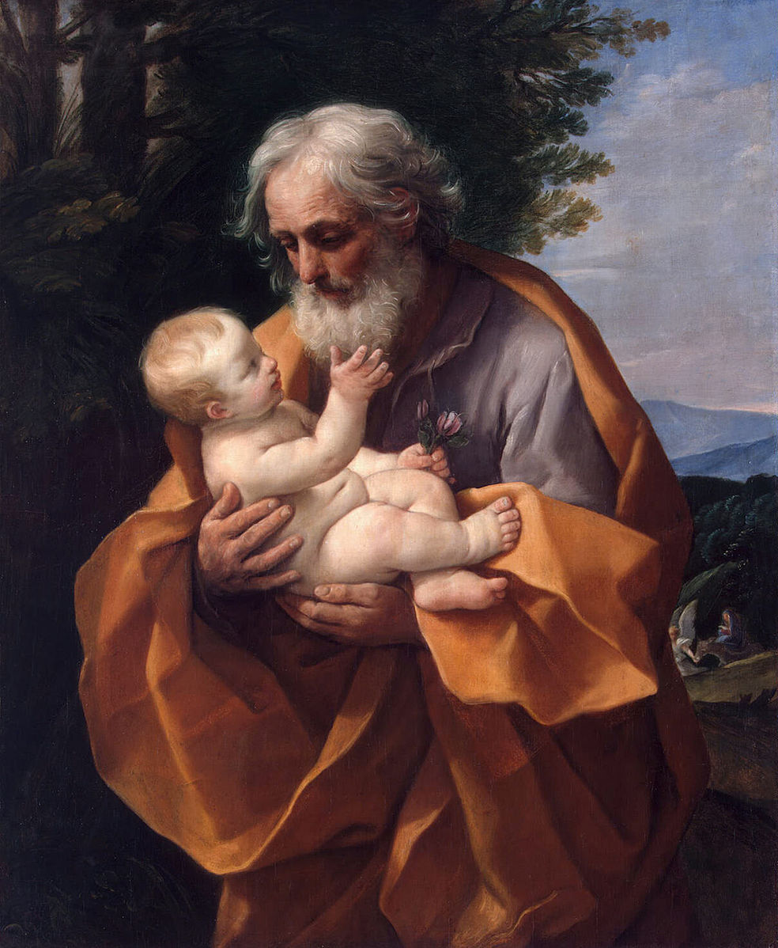
St. Joseph with the Infant Jesus, Guido Reni, 1620’s

Adam and Eve, Lucas Cranach the Elder, 1526
March 1-7, 2020: “For if, by the transgression of the one, death came to reign through that one, how much more will those who receive the abundance of grace and of the gift of justification come to reign in life through the one Jesus Christ.” (Romans 5:17)

We begin the first full week of Lent by recalling the Fall. The first reading from Genesis recounts the story of Adam and Eve succumbing to the enticement of the serpent rather than obeying God. Saint Paul in his letter to the Romans goes on to explain how this decision changed the course of history and impacted humankind ever since: “Through one man sin entered the world, and through sin, death, and thus death came to all men, inasmuch as all sinned…” (Romans 5:12).

But fortunately our story does not end here. In the Exsultet, sung at the Easter Vigil, we hear the words: “O happy fault that earned for us so great, so glorious a Redeemer.” In the Garden of Eden were plenty of trees from which Adam and Eve could eat and still they chose to disobey God and take from the Tree of the Knowledge of Good and Evil. Jesus, in the barren desert had fasted for 40 days and was hungry when the devil tempted him. And yet in complete obedience to his Father, he emerged victorious: “The tempter approached and said to him, ‘If you are the Son of God, command that these stones become loaves of bread.’ He said in reply, ‘It is written: One does not live on bread alone, but on every word that comes forth from the mouth of God.’” (Matthew 4:3-4)

Our Redeemer is so great, so glorious, that he withstood temptation and willingly suffered and died to offer us the “abundance of grace and the gift of justification.”

March 1: Lord, teach us how to resist temptation as we pray with Matthew 4:1-11.
____________________________________________________________________________________________________________________________________________________________________________________________________________________________________________________________________________________________________________________________________
March 2: Lord, show us how you’re inviting us to minister to you “in the least of these” as we pray with Matthew 25:31-46.
____________________________________________________________________________________________________________________________________________________________________________________________________________________________________________________________________________________________________________________________________
March 3: Lord, teach us how to pray as you taught the disciples in Matthew 6:7-15.
_____________________________________________________________________________________________________________________________________________________________________________________________________________________________________________________________________________________________________________________________________________________________________________________________________________________
March 4: Lord, help us as a Local Church to repent and receive forgiveness as the people of Nineveh did in Jonah 3:1-10.
_____________________________________________________________________________________________________________________________________________________________________________________________________________________________________________________________________________________________________________________________________________________________________________________________________________________
March 5: Lord, as we pray with Matthew 7:7-12, help us to ask, seek, and knock on the door of your heart to receive what you desire for us as an Archdiocese.
_____________________________________________________________________________________________________________________________________________________________________________________________________________________________________________________________________________________________________________________________________________________________________________________________________________________
March 6: Lord, help us to recognize and take advantage of the great gift of the Sacrament of Reconciliation as we pray with Ezekiel 18:21-28.
_____________________________________________________________________________________________________________________________________________________________________________________________________________________________________________________________________________________________________________________________________________________________________________________________________________________
March 7: Lord, teach us what it means to “be perfect as our heavenly Father is perfect” as we pray with Matthew 5:43-48.
_____________________________________________________________________________________________________________________________________________________________________________________________________________________________________________________________________________________________________________________________________________________________________________________________________________________

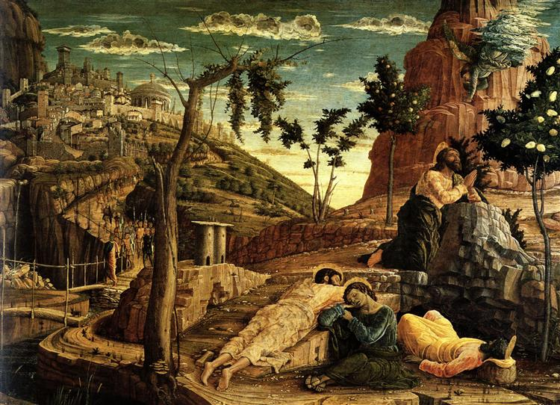
Prayer in the Garden, Andrea Mantegna, 1459

The Transfiguration of Christ, Peter Paul Rubens, 1605
March 8-14, 2020: “Jesus took Peter, James, and John his brother, and led them up a high mountain by themselves. And he was transfigured before them; his face shone like the sun and his clothes became white as light. And behold, Moses and Elijah appeared to them…” (Matthew 17:1-3)

The Church gives us a great gift in directing our attention to the Transfiguration during the season of Lent. In the midst of our striving for holiness through fasting, penance and almsgiving, we are given a preview of our goal. Sometimes it’s quite challenging to run the race before us, but catching a glimpse of the finish line can help us to persevere.

Perhaps that is why Peter, James, and John were privileged to witness the Transfiguration of Our Lord. Isn’t it interesting that they were the same three who fell asleep after Jesus invited them to “stay awake” with him in the Garden of Gethsemane? But after Christ’s death and resurrection and receiving the gift of the Holy Spirit, these three would get back in the race and continue to carry out the mission Our Lord entrusted to them.

Are we willing to take up the mission God has for us, trusting he will equip us to accomplish it? “We receive the Spirit of Truth so that we can know the things of God… This unique gift which is in Christ is offered in its fullness to everyone. It is everywhere available, but it is given to each man in proportion to his readiness to receive it. Its presence is the fuller, the greater a man’s desire to be worthy of it.” (From the treatise on the Trinity by Saint Hilary of Poiters)

Let us use this season of Lent to allow Christ to increase our desire so we will be ready to receive all that he wants to give us!

March 8: Lord, open our eyes to see that we too are your beloved children as we pray with Matthew 17:1-9.
____________________________________________________________________________________________________________________________________________________________________________________________________________________________________________________________________________________________________________________________________
March 9: Lord, teach us to be merciful as you are merciful as we pray with Luke 6:36-38.
____________________________________________________________________________________________________________________________________________________________________________________________________________________________________________________________________________________________________________________________________

March 10: Lord, reveal to us where we are not practicing what we preach as we pray with Matthew 23:1-12.
____________________________________________________________________________________________________________________________________________________________________________________________________________________________________________________________________________________________________________________________________
March 11: Lord, may our Local Church grow in humility and service to one another as we pray with Matthew 20:17-28.
_____________________________________________________________________________________________________________________________________________________________________________________________________________________________________________________________________________________________________________________________________________________________________________________________________________________
March 12: Lord, show us what it means to put our hope in you as we pray with Psalm 1.
_____________________________________________________________________________________________________________________________________________________________________________________________________________________________________________________________________________________________________________________________________________________________________________________________________________________
March 13: Lord, increase our resolve to never betray you as we pray with Matthew 21:33-46.
_____________________________________________________________________________________________________________________________________________________________________________________________________________________________________________________________________________________________________________________________________________________________________________________________________________________
March 14: Lord, may our Archdiocese be filled with gratitude for your kindness and mercy as we pray with Psalm 103.
_____________________________________________________________________________________________________________________________________________________________________________________________________________________________________________________________________________________________________________________________________________________________________________________________________________________

The Samaritan Woman at the Well, Annibale Carracci, second half of 16th century
March 15-21, 2020: “A woman of Samaria came to draw water. Jesus said to her, ‘Give me a drink.’” (John 4:7)

On March 25, 1993, Mother Teresa wrote a letter to the Missionaries of Charity in which she talked about Jesus’ thirst. As we contemplate this week’s Gospel account of Jesus and the woman at the well, let us spend some time reflecting on the words of this much-loved, modern-day saint:

"My dearest Children… Jesus wants me to tell you again… how much is the love He has for each one of you - beyond all that you can imagine. I worry some of you still have not really met Jesus - one to one - you and Jesus alone. We may spend time in chapel - but have you seen with the eyes of your soul how He looks at you with love?
Do you really know the living Jesus - not from books, but from being with Him in your heart? Have you heard the loving words He speaks to you? Ask for this grace, He is longing to give it. Never give up this daily intimate contact with Jesus as a real living Person - not just an idea.
…Jesus Himself must be the one to say to you ‘I Thirst.’ Hear your own name. Not just once. Every day. If you listen with your heart, you will hear, you will understand.
Why does Jesus say, ‘I thirst?’ What does it mean? Something so hard to explain in words - if you remember anything from Mother's letter, remember this – ‘I thirst’ is something much deeper than just Jesus saying ‘I love you.’ Until you know deep inside that Jesus thirsts for you - you can't begin to know who He wants to be for you. Or who He wants you to be for Him.” – St. Teresa of Calcutta

March 15: Lord, help us come to a deeper awareness of your thirst for us as we pray with John 4:5-42.
____________________________________________________________________________________________________________________________________________________________________________________________________________________________________________________________________________________________________________________________________
March 16: Lord, increase our thirst for you as we pray with Psalm 42.
____________________________________________________________________________________________________________________________________________________________________________________________________________________________________________________________________________________________________________________________________

March 17: Lord, show us where we need to forgive as we pray with Matthew 18:21-35.
_____________________________________________________________________________________________________________________________________________________________________________________________________________________________________________________________________________________________________________________________________________________________________________________________________________________
March 18: Lord, help us to see the blessing in obeying your commandments as we pray with Deuteronomy 4:5-9.
____________________________________________________________________________________________________________________________________________________________________________________________________________________________________________________________________________________________________________________________________
March 19: Lord, as we pray with Matthew 1:18-24 on the Solemnity of St. Joseph, let us pray for all fathers, that they may lead with humility, integrity, and love. And in a special way, let us pray for our Holy Father, Pope Francis, on the 7th Anniversary of his papal inauguration.
____________________________________________________________________________________________________________________________________________________________________________________________________________________________________________________________________________________________________________________________________
March 20: Lord, help our Archdiocese to love you and love our neighbor as we pray with Mark 12:28-34.
_____________________________________________________________________________________________________________________________________________________________________________________________________________________________________________________________________________________________________________________________________________________________________________________________________________________
March 21: Lord, help us to follow the example of the tax-collector and truly humble ourselves before you as we pray with Luke 18:9-14.
____________________________________________________________________________________________________________________________________________________________________________________________________________________________________________________________________________________________________________________________________

Jesus Opens the Eyes of a Man Born Blind, Duccio di Buoninsegna, 1308-1311
March 22-28, 2020: “Jesus answered, ‘Neither he nor his parents sinned; it is so that the works of God might be made visible through him.’” (John 9:2-3)

The story in John’s Gospel of Jesus healing of the man born blind is a great example of the power of a personal testimony. When Christ changes a life, people notice. We see this clearly in the life of this man: “His neighbors and those who had seen him earlier as a beggar said, ‘Isn’t this the one who used to sit and beg?’ Some said, ‘It is,’ but others said, ‘No, he just looks like him.’ He said, ‘I am.’ So they said to him, ‘How were your eyes opened?’ He replied, ‘The man called Jesus made clay and anointed my eyes and told me, “Go to Siloam and wash.” So I went there and washed and was able to see.’” (John 9:8-11)

In Matthew 28:19, Jesus commands his followers to “go and make disciples of all nations.” One of the most natural ways to do this is to share the way Jesus is working in our lives. In one of his letters St. Peter says, “Always be ready to give an explanation to anyone who asks you for a reason for your hope, but do it with gentleness and reverence…” (1 Peter 3:15b-16a)

This Lent let us take some extra time to examine our lives. When people look at us, let us pray that they see Jesus: “Dear Jesus, help me to spread your fragrance everywhere I go. Flood my soul with your spirit and life. Penetrate and possess my whole being so utterly, that my life may only be a radiance of yours. Shine through me, and be so in me that every soul I come in contact with may feel your presence in my soul. Let them look up and see no longer me, but only Jesus!” (Prayer of St. John Henry Newman and source for the motto for Archbishop Hebda’s Archdiocesan crest.)

March 22: Lord, as we pray with John 9:1-41, transform our lives so that people no longer see us, but rather see you.
____________________________________________________________________________________________________________________________________________________________________________________________________________________________________________________________________________________________________________________________________
March 23: Lord, show us how you desire to restore our Archdiocese as we pray with Isaiah 65:17-21.
____________________________________________________________________________________________________________________________________________________________________________________________________________________________________________________________________________________________________________________________________

March 24: Lord, help us to take refuge in you as we pray with Psalm 46.
____________________________________________________________________________________________________________________________________________________________________________________________________________________________________________________________________________________________________________________________________
March 25: Lord, as we pray with Luke 1:26-38 on the Solemnity of the Annunciation, let us follow the example of our Blessed Mother in making our own personal “fiat” – “May it be done unto me according to your word.”
____________________________________________________________________________________________________________________________________________________________________________________________________________________________________________________________________________________________________________________________________
March 26: Lord, as we pray with Exodus 32:7-14, help us to recognize and repent of the ways we have turned away from you in disobedience.
_____________________________________________________________________________________________________________________________________________________________________________________________________________________________________________________________________________________________________________________________________________________________________________________________________________________
March 27: Lord, you are close to the brokenhearted. Redeem us as we pray with Psalm 34:17-32.
_____________________________________________________________________________________________________________________________________________________________________________________________________________________________________________________________________________________________________________________________________________________________________________________________________________________
March 28: Lord, as we pray with Psalm 7, let us see that you are our refuge.
____________________________________________________________________________________________________________________________________________________________________________________________________________________________________________________________________________________________________________________________________

The Raising of Lazarus, Vincent van Gogh, 1890
March 29 – April 4, 2020: “He cried out in a loud voice, ‘Lazarus, come out!’” (John 11:43)

There is a temptation to get frustrated when God doesn’t answer our prayers in the manner and timeframe we desire. Imagine the confusion the disciples, Mary, and Martha must have felt when they asked Jesus to come and heal Lazarus. The sisters sent word to Jesus, “Master, the one you love is ill.” (John 11:3). But then we read our Lord’s unexpected response: “Now Jesus loved Martha and her sister and Lazarus. So when he heard that he was ill, he remained for two days in the place where he was.” (John 11:5) This doesn’t seem to make sense. His followers have witnessed him healing people day in and day out. Why is he not willing to go immediately to do the same for his friends?

What we see here and what we need to remember in our own lives is that God knows what he is doing! He is always willing our good – our ultimate good.

With creation, God does not abandon his creatures to themselves. He not only gives them being and existence, but also, and at every moment, upholds and sustains them in being, enables them to act and brings them to their final end. Recognizing this utter dependence with respect to the Creator is a source of wisdom and freedom, of joy and confidence:

For you love all things that exist, and detest none of the things that you have made; for you would not have made anything if you had hated it. How would anything have endured, if you had not willed it? Or how would anything not called forth by you have been preserved? You spare all things, for they are yours, O Lord, you who love the living. (CCC 301)

Jesus could have easily healed Lazarus. But he wanted to do something more, he wanted to resurrect him. What does God want to resurrect in us?

March 29: Lord, help us to entrust everything to you as we pray with John 11:1-45.
____________________________________________________________________________________________________________________________________________________________________________________________________________________________________________________________________________________________________________________________________
March 30: Lord, we praise and thank you for being our Good Shepherd as we pray with Psalm 23.
____________________________________________________________________________________________________________________________________________________________________________________________________________________________________________________________________________________________________________________________________

March 31: Lord, open our eyes and hearts to see you more clearly as we pray with John8:21-30.
_____________________________________________________________________________________________________________________________________________________________________________________________________________________________________________________________________________________________________________________________________________________________________________________________________________________
April 1: Lord, increase our courage and strength to follow you even in the midst of persecution as we pray with Daniel 3:13-25.
_____________________________________________________________________________________________________________________________________________________________________________________________________________________________________________________________________________________________________________________________________________________________________________________________________________________
April 2: Lord, bless our families and show us how to pass on our faith to future generations as we pray with Genesis 17:3-9.
_____________________________________________________________________________________________________________________________________________________________________________________________________________________________________________________________________________________________________________________________________________________________________________________________________________________
April 3: Lord, be our rock of refuge as we pray with Psalm 18.
_____________________________________________________________________________________________________________________________________________________________________________________________________________________________________________________________________________________________________________________________________________________________________________________________________________________
April 4: Lord, gather together the people of our Local Church and make us holy as we pray with Ezekiel 37:21-28.
_____________________________________________________________________________________________________________________________________________________________________________________________________________________________________________________________________________________________________________________________________________________________________________________________________________________

